Task 01:
class Animal {
void sound() {
sout(" sounds of different animals");
}
}
class Cat extends Animal{
@Override
void sound() {
sout(" Meow is the sound of cat");
}
}
class Main{
psvm(String[] args) {
Animal obj = new Cat();
obj.sound(); //Meow is the sound of cat
}
}
issue with Substitution and Generics

Java Generics -- it has introduced a challenge - substitution principle...

is cat a subtype of Animal, List<cat> is not a subtype of List<Animal>

List<Cat> Cobj = new ArrayList<>();
List<Animal> Aobj = Cobj; ===// this will give you a wildcard ,

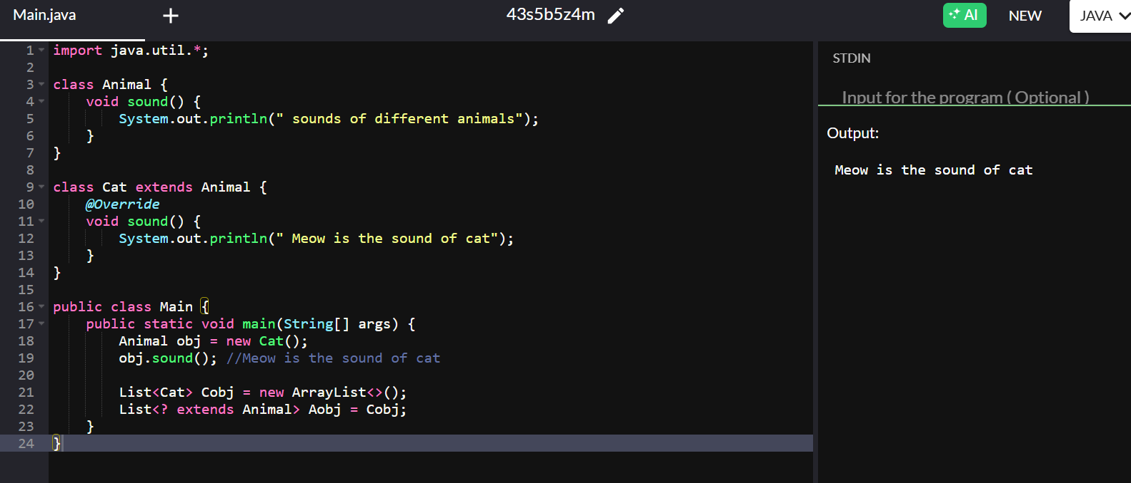

Task 02:
they are useful when the code does not depends on the actual type parmeter

void printList(List<?> list) {
for(Object element: list) {
sout (element);
}
}

List<Cat> clist = new ArrayList<>();
clist.add(new Cat());
printList(clist); //

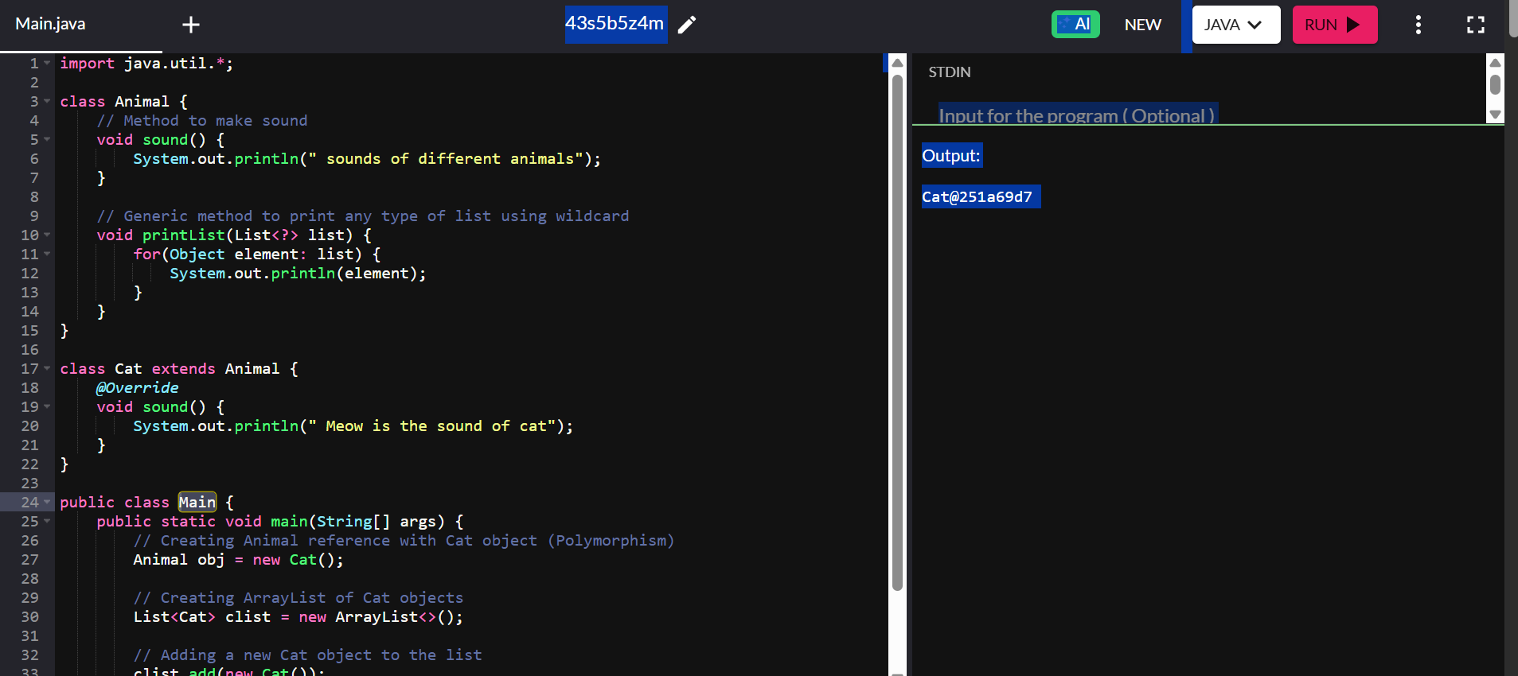

Task 03:

Upper Bounded Wildcards

void animalSound(List<? extends Animal> animalList) {
for(Animal elements : animalList
elements.sound();
}
}
List<Cat> cats = new ArrayList<>();
cats.add(new Cat());
animalSound(cats); //meow

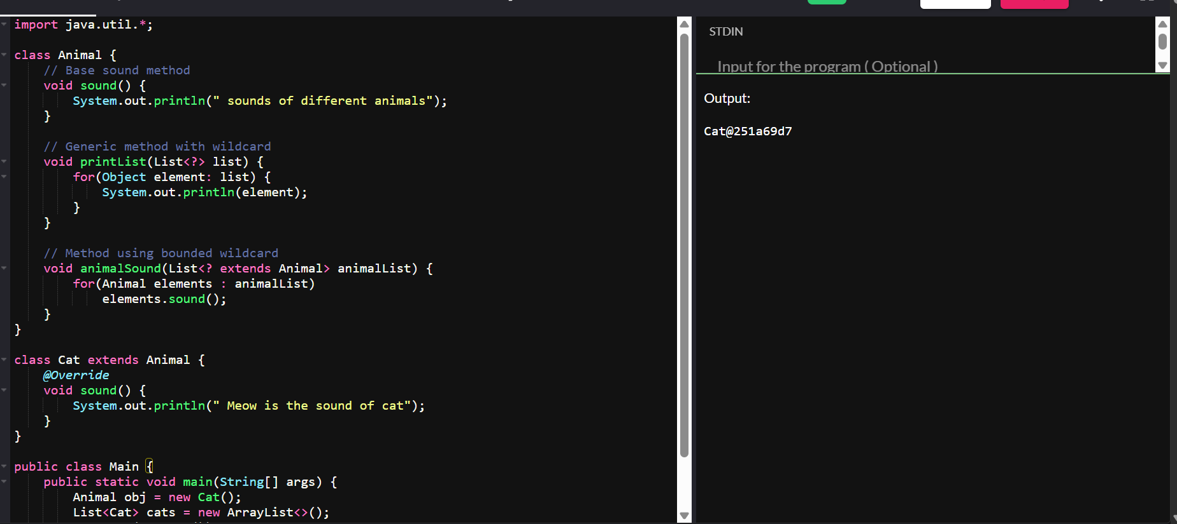

\

Task 04:
lower Bounded Wildcards
void addAcat(List<? super Cat> cats) {
cats.add(new Cat());
}
List<Animal> animals = new ArrayList<>();
addAcat(animals); /
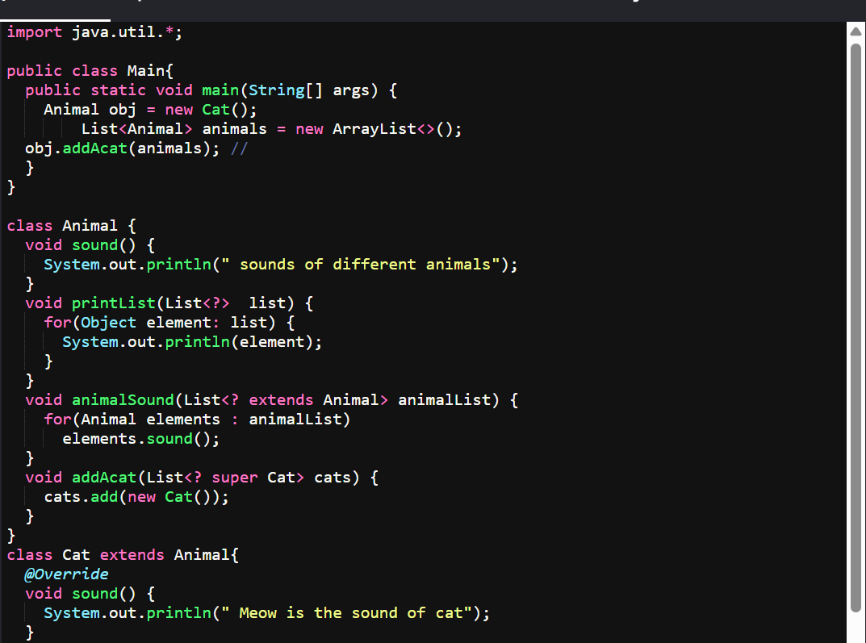

Task 05:

class Student {
public int roll_no = 10;

public int getRoll() {
System.out.println("getRoll method");
return roll_no;
}

public void setRoll(int roll) {
if(!(roll > 100))
roll_no = roll;
}
}

public class Tight_coupling {
public static void main(String[] args) {
Student sobj = new Student();
sobj.roll_no = 10;
System.out.println("The roll no of student is " + sobj.roll_no);
}
}

Task 06:

class Student {
private int roll_no = 0;
public int getRoll() {
System.out.println("getRoll method");
return roll_no;
}

public void setRoll(int roll) {
if(!(roll > 100))
roll_no = roll;
}
}

public class Loose_coupling {
public static void main(String[] args) {
Student sobj = new Student();
sobj.setRoll(10);
System.out.println("The roll no of student is " + sobj.getRoll());
}
}

Task 07:

class LightBulb {
void turnOn() {
System.out.println("Light turned on");
}

void turnOff() {
System.out.println("Light is off");
}
}

class Switch {
LightBulb lbulbobj;

Switch(LightBulb lbulbobj) {
this.lbulbobj = lbulbobj;
}

void operate() {
lbulbobj.turnOn();
}

public static void main(String[] args) {
LightBulb lbulbobj = new LightBulb();
Switch switchObj = new Switch(lbulbobj);
switchObj.operate();
}
}
Task 08:

interface SwitchOnOff {
void turnOn();
void turnOff();
}

class LightBulb implements SwitchOnOff {
@Override
public void turnOn() {
System.out.println("Light turned on");
}

@Override
public void turnOff() {
System.out.println("Light is off");
}
}

class Fan implements SwitchOnOff {
@Override
public void turnOn() {
System.out.println("Fan turned on");
}

@Override
public void turnOff() {
System.out.println("Fan is off");
}
}

class Switch {
private SwitchOnOff device;

public Switch(SwitchOnOff device) {
this.device = device;
}

public void operate() {
device.turnOn();
}
}

public class DIP {
public static void main(String[] args) {
SwitchOnOff lightBulb = new LightBulb();
Switch lightSwitch = new Switch(lightBulb);
lightSwitch.operate();

SwitchOnOff fan = new Fan();
Switch fanSwitch = new Switch(fan);
fanSwitch.operate();
}
}

Task 9:
Why should we choose Composition over Inheritance?

Loose Coupling
Inheritance: Creates tight parent-child dependency
Composition: Objects remain independent, interact via interfaces
Result: Easier to modify and maintain code
Flexibility
Inheritance: Fixed at compile time
Composition: Can change behavior at runtime
Result: More adaptable to changing requirements
Better Encapsulation
Inheritance: Child classes can access parent's internals
Composition: Objects interact only through public interfaces
Result: Better information hiding and security

